**Design Decisions**

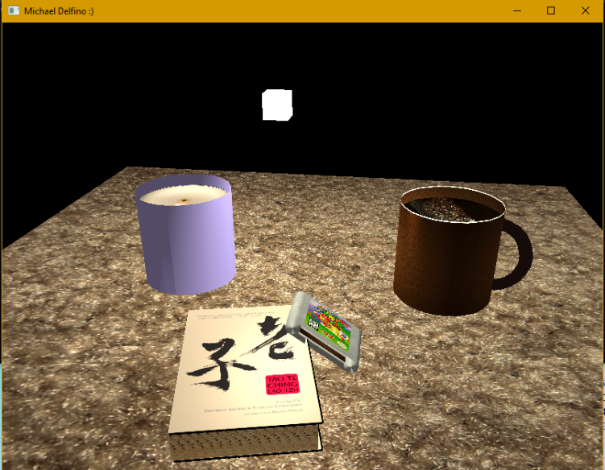 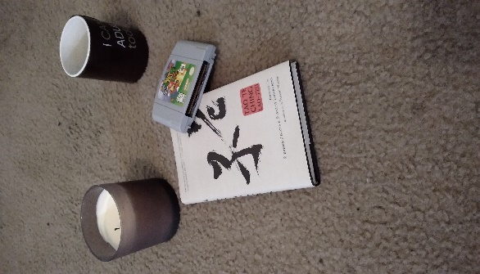

The figures shown above are my completed 3D scene compared with the original picture I took at the start of the course.

There were many difficult development decisions that I had to make in order to create this final product. One of the first was how to render a cylinder. All of my shapes required the input of vertices in space to construct the mesh, and while creating simple objects like pyramids and cubes was rather simple, a cylinder proved to be rather complex to conceptualize in these terms. I ended up using Desmos, a glorified graphing calculator, to graph the vertices of a circle and I pulled those into my code. I also used this graphing method to calculate the normal vectors that I used in lighting the cylinder. Rendering the coffee cup handle was my next big hurdle. Since my previous graphing solution wouldn’t apply to torus vertices, my work-around was to actually render two cylinders instead. I rendered one smaller cylinder in the stencil buffer that didn't actually display the fragments, then rendered a second larger cylinder only where the first didn't exist. Resulting in a cylinder with a hole in the middle, or a coffee cup handle.

I set up the camera control in a way to allow the user to use the mouse for looking around the viewport and the WASD, E/Q keys for movement laterally within the scene. I also implemented mouse-wheel functionality that controls the speed of the user’s movement throughout the scene.

Throughout writing the code for this scene I was consciously focusing on making the code not only maintainable and readable, but adaptable as well. One example of this is my UCreateMesh() function. Since I knew there would be many different meshes that would need to be rendered in the scene, I passed in an identifier value depending on the shape I needed to create, and the function created the vertices and indices depending on the identifier. This way there was only one function rather than one for each. 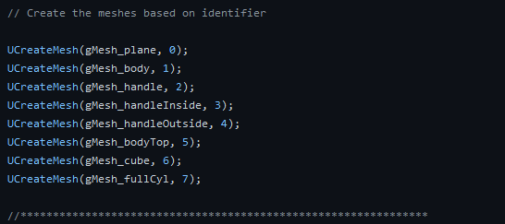

Likewise, I also used a render function that allowed passing in multiple meshes, this way I used the one URender() function instead of multiple.



This project was often arduous and time-consuming, however I am quite proud with how well it turned out, and each of my design decisions along the way, difficult or creative, contributed to this final product.